**C:\Users\User\AppData\Local\Microsoft\Windows\INetCache\Content.Word\iKcom.png**

# Category 8.1/ Class 1 Shielded Keystone Jack

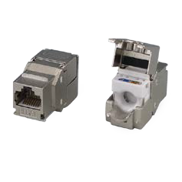

Category 8.1/Class I shielded keystone jack supports high-speed protocols: 25GBASE-T and 40GBASE-T up to 30 Meters according ISO/IEC 11801 2nd edition ANSI/TIA/EIA-568.2-D

Zinc-alloy metal shell provides immunity against EMI and eliminates the Alien crosstalk while the data is at high speed transmission. The Category 8.1/Class I shielded keystone jack complaints 4PPoE for IEEE 802.3bt Type 4 power over Ethernet. High Density design fits 24 ports in half unit panel or 48 ports in on unit panel for most efficient use of rack space.

# Features

Zinc-alloy metal shell

Tool-free, no additional tool required for termination

Contacts are phosphor bronze plated with 50 micro inches hard gold Dual T568A & T568B wiring

Polycarbonate 94V0 rated

Force EC Cat.8/Class I Channel certified

4PPoE compliant in accordance with IEEE802.bt Type 4

# Ordering Information

|  |  |
| --- | --- |
| PART | Description |
| 1B88TPZ00 | RJ45, 8-Conductor Cat.8.1/Class I, Tool-free, Shielded, 180 degree, H.D. version |
| 7B88TPZ00 | RJ45, 8-Conductor Cat.8.1/Class I, Tool-free, Shielded, 180 degree, H.D. version |